Symptom History

Patient Name:_____________________________________________________________________________________

Diagnosis:

Date of Injury / Surgery:

Have you ever had this type of injury before? ◻ Yes ◻ No If yes, please explain:

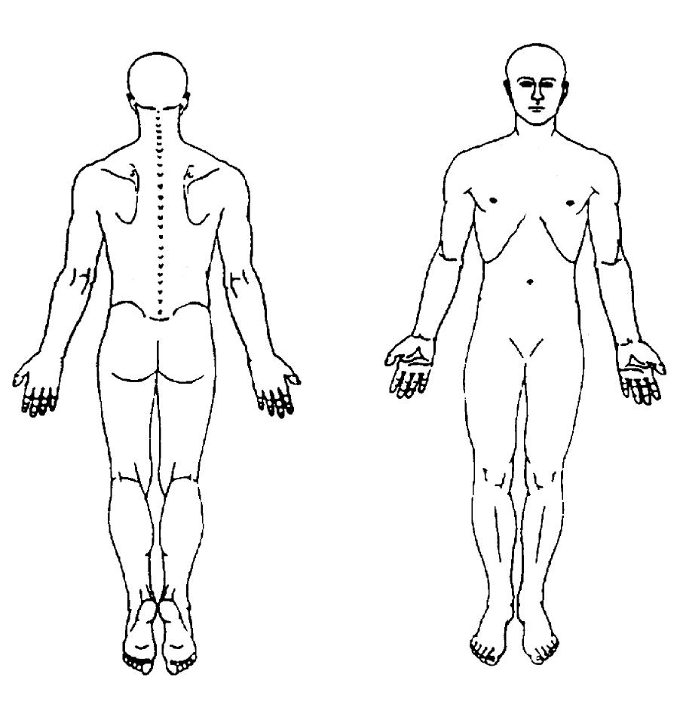
Where are your symptoms for which you are seeking treatment? Mark the areas below where you feel your symptoms.

Le
f
t

R
i
g
h
t

Lef
t

R
i
g
h
t

What was your worst pain rating within the last 2 days? Please circle below

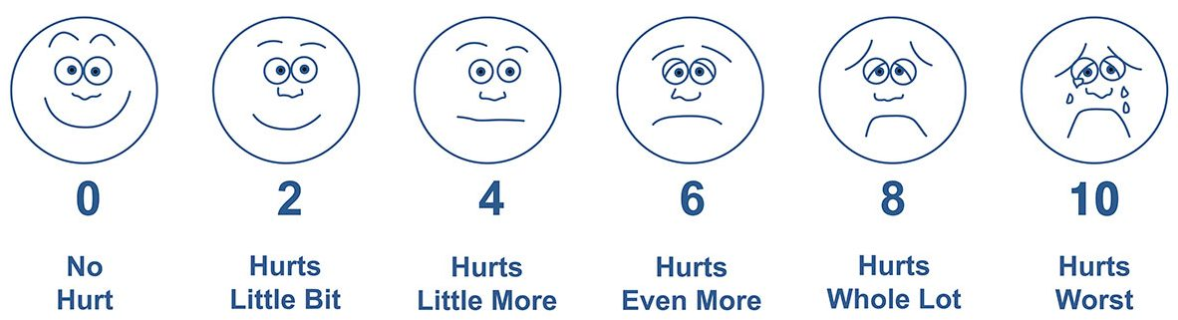

What makes your symptoms worse?
- What, if anything, eases your symptoms?

Currently would you say that your health is EXCELLENT, VERY GOOD, FAIR, or POOR? (Circle one)
- What would you like to be able to do that you currently cannot do? Please list goals below
What are your goals for Physical Therapy?
GOAL 1:
GOAL 2:

Have you received any recent medical tests or imaging?

◻ Yes ◻ No If Yes: what? ______________________________ ____________________________________

Do you currently have or have you had any of the following? Please check below
 | YES |  | NO |  |  | YES |  | NO
Asthma, Bronchitis or Emphysema |  |  |  |  | Cancer or Chemotherapy
Shortness of Breath |  |  |  |  | Arthritis / Swollen Joints
Smoker |  |  |  |  | Bowel or Bladder Problems
(If Yes How much? ______________________) |  |  |  |  | Allergies
Coronary Heart Disease or Chest Pain |  |  |  |  | Severe or Frequent Headaches
Pacemaker |  |  |  |  | Vision or Hearing Difficulties
High Blood Pressure |  |  |  |  | Do you have a history of falling?
Stroke/TIA/Head Injury/Blood Clot/Emboli |  |  |  |  | Gout
Nausea or Vomiting |  |  |  |  | Numbness or Tingling
Thyroid Trouble or Goiter |  |  |  |  | Dizziness or Fainting
Varicose Veins |  |  |  |  | Weight Loss / Energy Loss
Anemia |  |  |  |  | Epilepsy / Seizures
Infectious Diseases |  |  |  |  | Joint Replacement / Metal Implants
Diabetes |  |  |  |  | Hepatitis / Liver Disease
Women Only: Are You Pregnant? |  |  |  |  | Osteoporosis or Osteopenia

MEDICATIONS (please or attach a list or list all medications you are currently taking):

SURGERIES (please list all surgeries and approximate dates):

As part of our quality program, we believe that patients should be integrally involved in their rehabilitation plan. This includes being informed about the treatment recommended, as well as the goals of your program. It is important that you understand you have the right to refuse any part of the treatment your therapist recommends.

Signature: Date:

